Electric energy from trubines in oceans

ocean and wind energy

Marine energy, also known as marine and hydrokinetic energy or marine renewable energy, is a renewable power source that is harnessed from the natural movement of water, including waves, tides, and river and ocean current.

Wind power or wind energy is a form of renewable energy that harnesses the power of the wind to generate electricity. It involves using wind turbines to convert the turning motion of blades, pushed by moving air (kinetic energy) into electrical energy (electricity).

# Disadvantage of generating enery from waves

Draw back Generating energy from waves can be dangerous for some nearby species. Machinery can alter the seabed, change habitats near the coast, and generate noise pollution. There is also some risk of spilling toxic chemicals into the water. Another drawback is that it disturbs commercial and private vessels.wind turbines can be noisy and unappealing aesthetically and can sometimes adversely impact the physical environment around them. Similar to solar power, wind power is also intermittent, meaning that turbines are reliant on weather and therefore aren't capable of generating electricity 24/7.

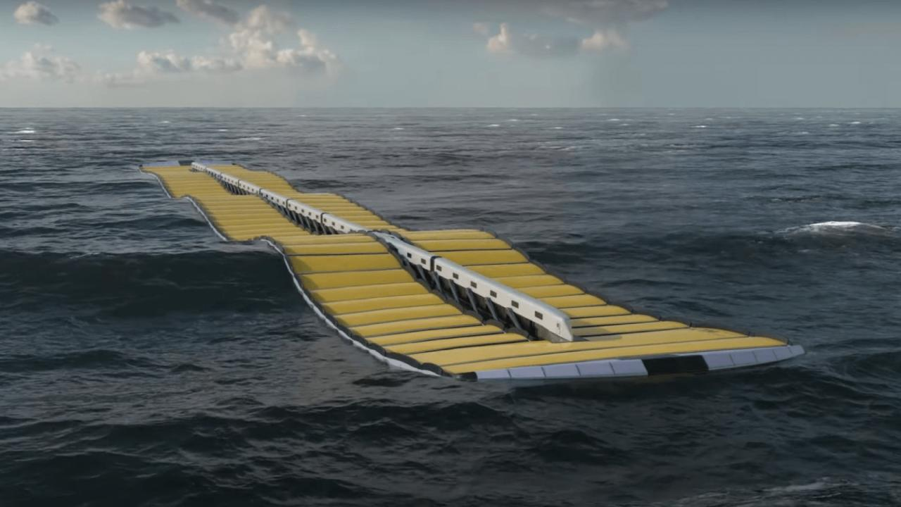To overcome these problems… we can introduce a small turbine that floating on the oceans can be introduced

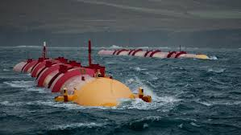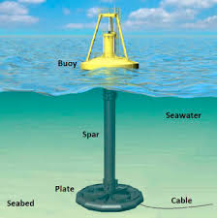Ocean waves can be converted into electrical energy. There are several technologies that can be used to convert ocean waves into electrical energy. Examples are overtopping devices, type buoys, and oscillating water columns. The technology is implemented in a power plant. There are two types of wave power plants based on their location, offshore or onshore.

In short, ocean waves generate electricity by utilizing kinetic energy to drive turbines which will generate electrical energy. To generate electricity, ocean waves must have strength and consistent intensity with a wave height of more than 3 meters.Ocean waves can be converted into electrical energy. There are several technologies that can be used to convert ocean waves into electrical energy. Examples are overtopping devices, type buoys, and oscillating water columns. The technology is implemented in a power plant. There are two types of wave power plants based on their location, offshore or onshore.

In short, ocean waves generate electricity by utilizing kinetic energy to drive turbines which will generate electrical energy. To generate electricity, ocean waves must have strength and consistent intensity with a wave height of more than 3 meters.

# Potential and Challenges of Implementing Ocean Wave Energy

Ocean waves have good potential to generate electrical energy. The world’s sea area reaches 361.1 million kilometers (71%). In addition, ocean waves are always available in nature so they can be used sustainably. Waves can generate large amounts of electrical energy to meet people’s needs. This energy source is also eco-friendly because it has minimal carbon emissions.

However, great potential always has a downside. The implementation has many challenges. Location determination is a bit tricky. Power plants must be built in sea areas that have high waves with consistent wave strength and intensity. Moreover, the cost of building a power plant is also prohibitive. It requires sophisticated technology and infrastructure that can endure extreme weather. Furthermore, the construction of a power plant in the sea possibly disrupts the stability of the surrounding marine ecosystem.

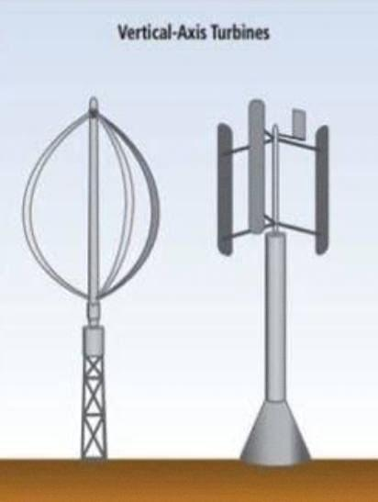Currently, several countries have utilized ocean waves to generate electricity. They are Sweden, Scotland and England. Sweden is the country with the world’s largest ocean wave energy test rig. The power plant is managed by the CorPower Ocean company.

1. *Advanced Materials*: Develop more efficient, durable, and corrosion-resistant materials for the piston and other components.
2. *Modular Design*: Create modular, scalable systems for easier deployment and maintenance.
3. *Energy Storage Integration*: Incorporate energy storage solutions to stabilize power output and ensure a steady supply.
4. *Subsea Installation*: Explore subsea installation options to reduce visual impact and increase energy capture.
5. *Hybrid Systems*: Combine ocean piston energy with other renewable sources (e.g., wind, solar) for a hybrid power generation system.
6. *Artificial Intelligence Optimization*: Implement AI to optimize energy production, predict maintenance needs, and improve overall efficiency.
7. *Marine Life Protection*: Develop innovative solutions to minimize environmental impact and protect marine life.
8. *Floating Cities*: Envision ocean piston energy as a power source for sustainable floating cities or coastal communities.
9. *Hydrogen Production*: Use ocean piston energy to power electrolysis and produce hydrogen fuel.
10. *Global Deployment*: Develop strategies for deploying ocean piston energy in diverse marine environments worldwide.

**BY**

**Protons**

**S5 EEE**